Using Infographics in Chemistry

Introduction

What:
This lesson focuses on developing an infographic.

Why:
This lesson will set you up for success in your chemistry project.

Where:
You will use the information in this lesson in your chemistry project, but the development process and design principles you will learn about are transferable to any project where you need to communicate with a specific group.

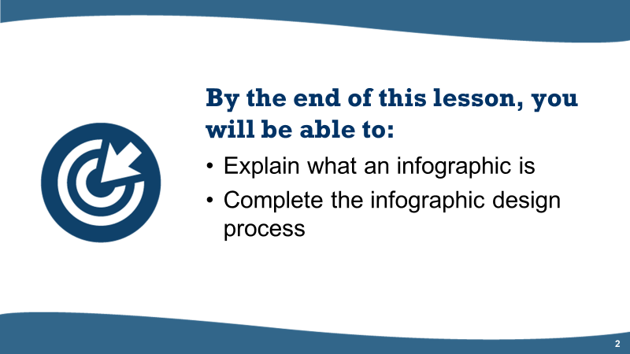
Figure 1 The Learning objectives for the using infographics in chemistry lesson

Part One: What is an infographic?
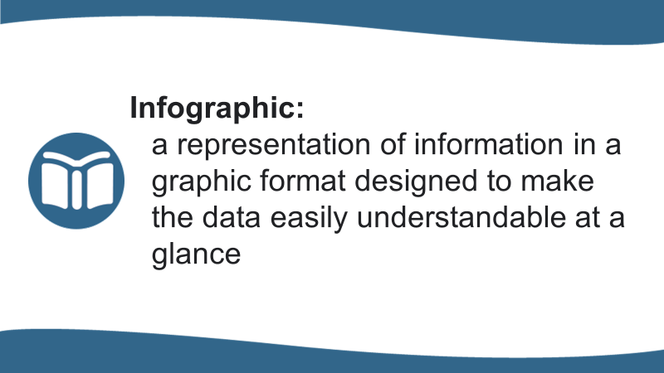
Slide 3
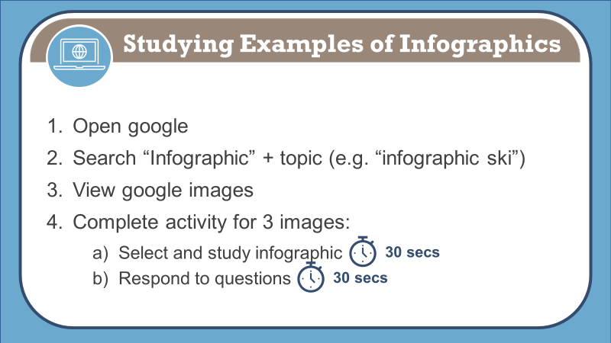 Slide 4
 | Infographic #1 | Infographic #2 | Infographic #3
What was the main idea of the infographic or the big question the infographic answered? | I don’t know | I don’t know | I don’t know
Who is the target audience?
What did you like or what made it easy to understand the message?
What didn’t you like or what made it hard to understand?

 | 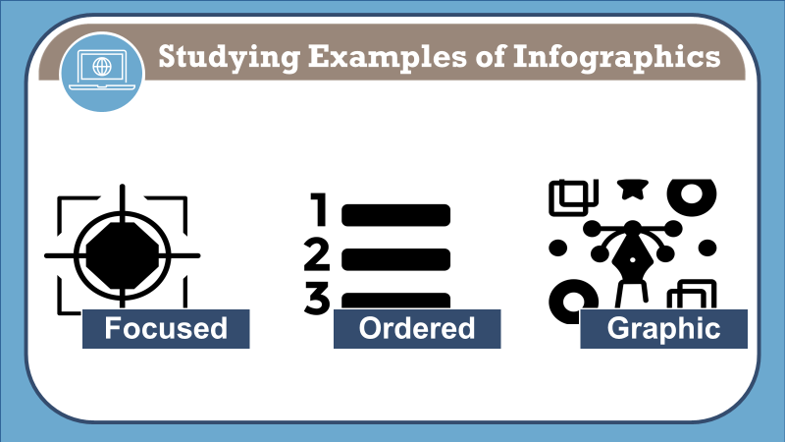Slide 5
An infographic should be:
- focused - one single message; emphasize the significance to the target audience
- ordered - the sequence should be obvious; simple flow paths and cues should guide the reader
- graphic - graphics and images tell the story (fewer than 800 words total)

Part Two: Infographic Design Process
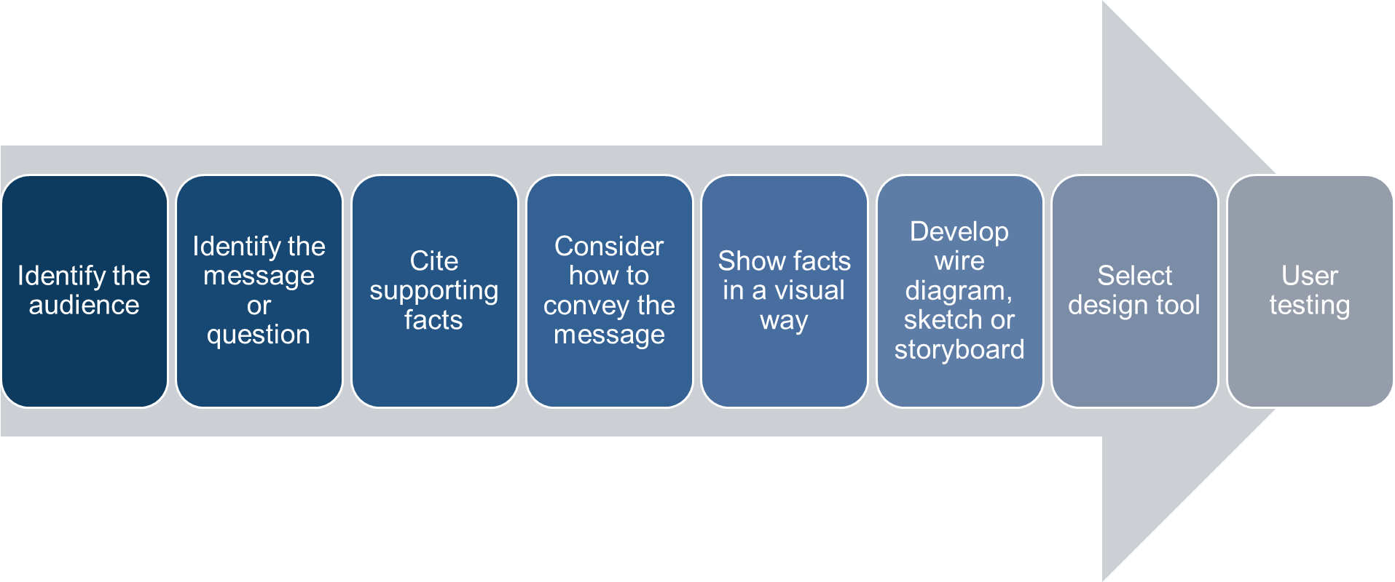

Slide 7
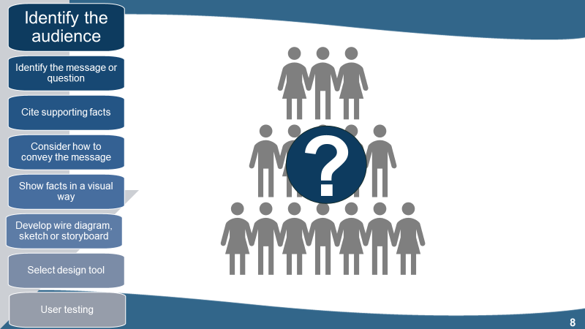  Slide 8 |  |  | Understanding your audience can help you design communication materials that relate to them and address their concerns.
Primary audience (members of the dragonfly parenting group):
_______________________________________________________________
_______________________________________________________________
_______________________________________________________________
_______________________________________________________________
_______________________________________________________________
_______________________________________________________________
_______________________________________________________________
_______________________________________________________________
Secondary audience?
_______________________________________________________________
_______________________________________________________________

To help you relate to your target audience, create 3 personas (pretend people you could envision as part of the group):
Persona #1
Age: ___________
Gender: ________________
Primary Language: ______________________
Education / Work Experience: ____________________________________________________
Name:

____________________________________________________
Profile: Describe them in 3-5 words
__________________________________________________________________________
Pain Points: List potential pain points that will affect this persona (what are they worried about?)
__________________________________________________________________________
__________________________________________________________________________
Key Drivers/Motivation: What makes the persona tick? What will the persona achieve?
__________________________________________________________________________
__________________________________________________________________________
Validations: Which input helps this person to make a decision? What do they find convincing?
__________________________________________________________________________
__________________________________________________________________________

Persona #2
Age: ___________
Gender: ________________
Primary Language: ______________________
Education / Work Experience: ____________________________________________________
Name:

____________________________________________________
Profile: Describe them in 3-5 words
__________________________________________________________________________
Pain Points: List potential pain points that will affect this persona (what are they worried about?)
__________________________________________________________________________
__________________________________________________________________________
Key Drivers/Motivation: What makes the persona tick? What will the persona achieve?
__________________________________________________________________________
__________________________________________________________________________
Validations: Which input helps this person to make a decision? What do they find convincing?
__________________________________________________________________________
__________________________________________________________________________

Persona #3
Age: ___________
Gender: ________________
Primary Language: ______________________
Education / Work Experience: ____________________________________________________
Name:

____________________________________________________
Profile: Describe them in 3-5 words
__________________________________________________________________________
Pain Points: List potential pain points that will affect this persona (what are they worried about?)
__________________________________________________________________________
__________________________________________________________________________
Key Drivers/Motivation: What makes the persona tick? What will the persona achieve?
__________________________________________________________________________
__________________________________________________________________________
Validations: Which input helps this person to make a decision? What do they find convincing?
__________________________________________________________________________
__________________________________________________________________________

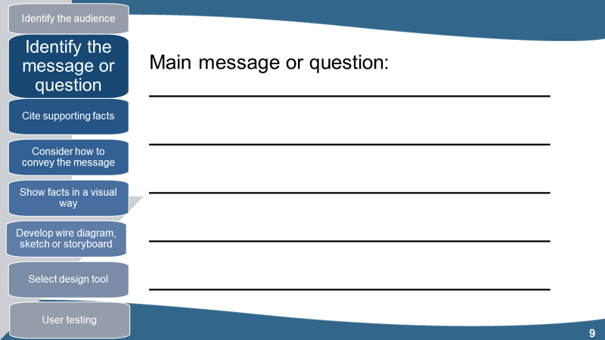
Slide 9
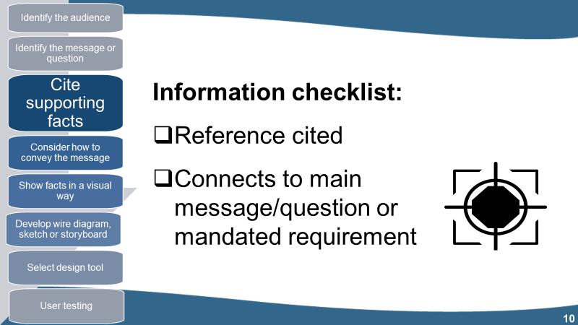 Slide 10
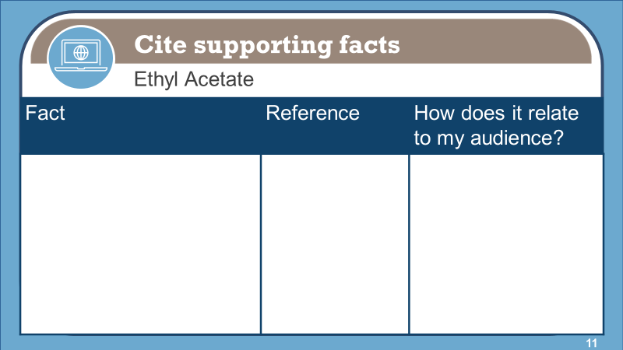
Slide 11

Identify supporting facts & citation
- Ingredients:
Name | Formula | Atomic Mass | Image of chemical structure | References
- Compound:
Solid, liquid or gas at room temperature? Reference:_______________________________
- Useful Facts:
Fact | Reference | How does it relate to my audience?

- Useful Facts (continued):
Fact | Reference | How does it relate to my audience?

Ref: https://youtu.be/A6_7zC0mB9w | 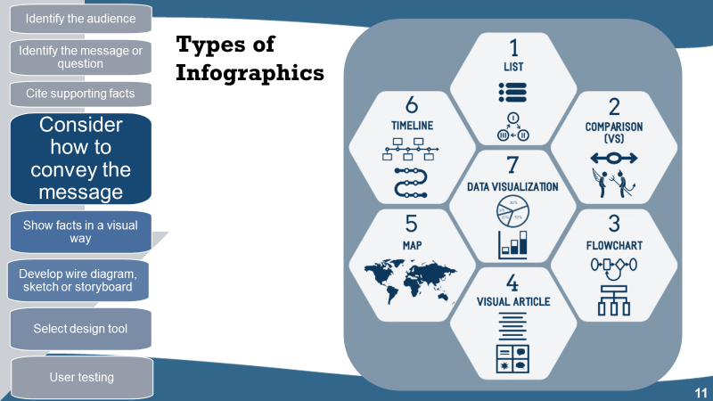Slide 11
List
- supports a claim through a series of steps
- best used to support a specific claim or argument
- list can go from top to bottom, left to right, or follow a path
Comparison or versus
- compares two things in a head-to-head study
- best used to highlight differences between two similar things or highlight similarities between two unlike things
- is also used to prove how one option is superior or inferior to the other option.
Flowchart
- provides a specific answer to reader choices
- best used to provide personalized answers for readers or show how multiple situations can reach the same conclusion
Visual article
- makes a piece of writing more visual
- best used to cut down on text or make an article more interesting and enjoyable to consume
- increases sharing potential through social media
Map
- showcases data trends based on location
- best used to compare places, culture, and people through setting centric data and demographics
Timeline
- tells a story through chronological flow
- best used to show how something has changed over time or make a long, complicated story easier to understand
- shows how one thing leads to another
Data visualization
- communicates data through charts and graphs
- best used to make data-driven arguments easier to understand and make facts or statistics more interesting to absorb
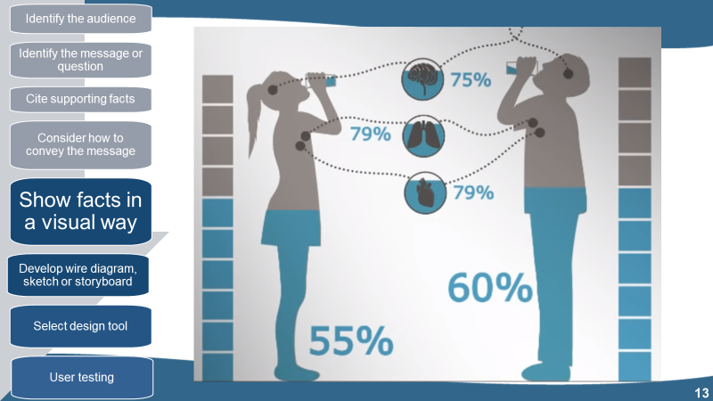
Slides 13 & 14
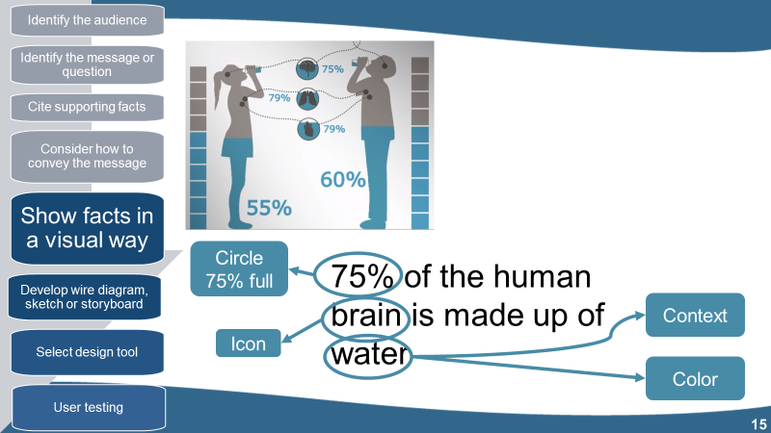
Slide 15
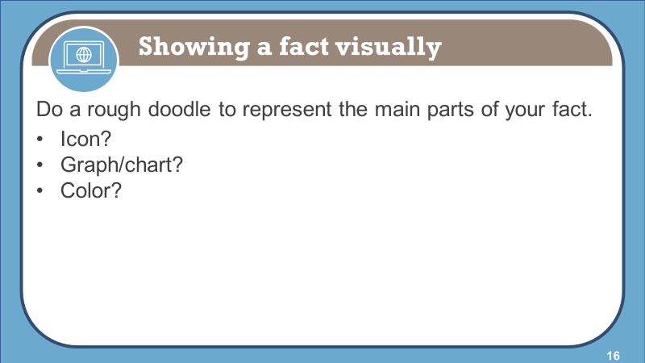
Slide 16
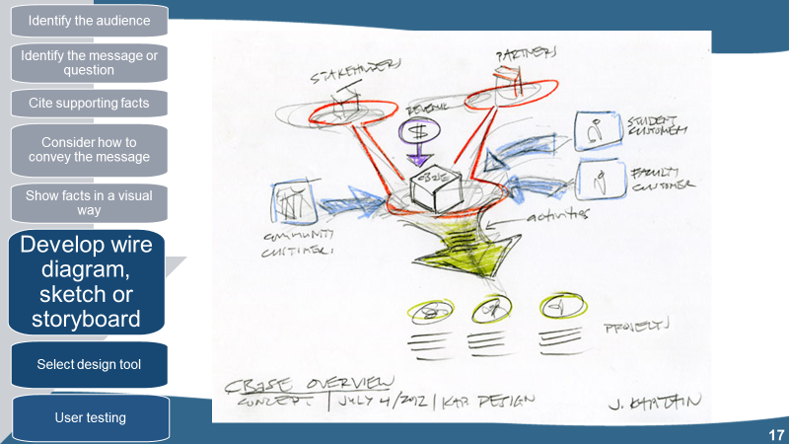
Slide 17
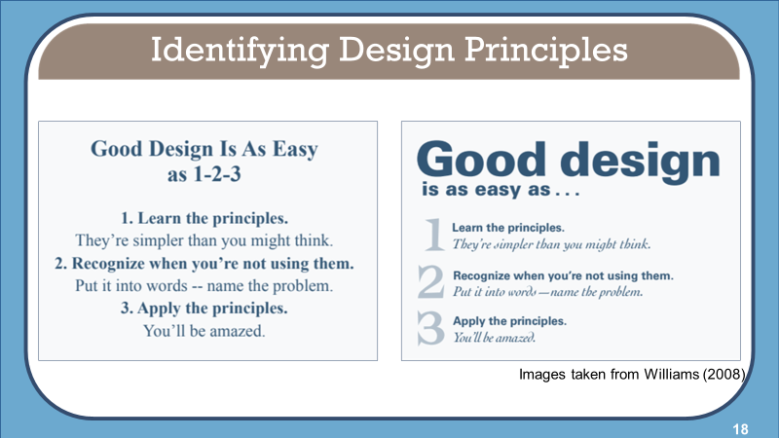
Slide 18

Why is the graphic on the right better than the one on the left?
_______________________________________________________________
_______________________________________________________________
_______________________________________________________________
_______________________________________________________________
_______________________________________________________________
_______________________________________________________________
_______________________________________________________________
_______________________________________________________________
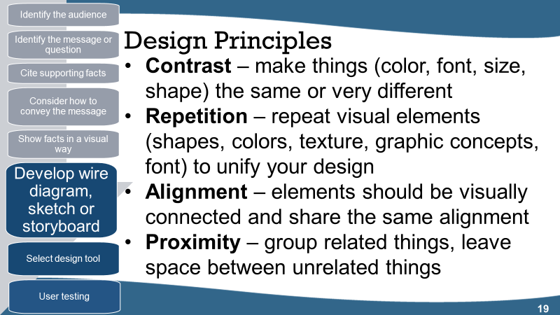
Slide 19
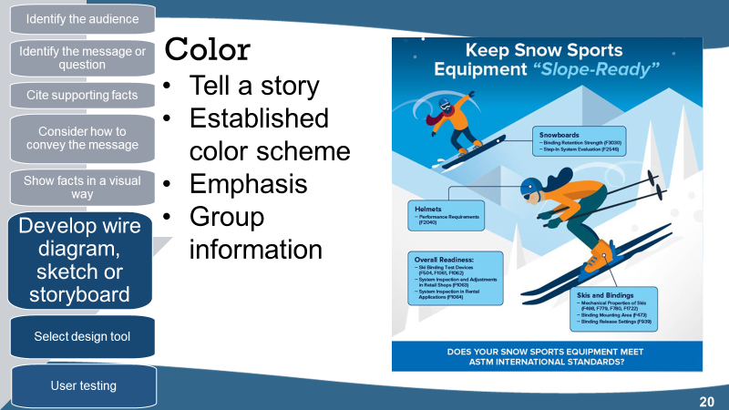
Slide 20

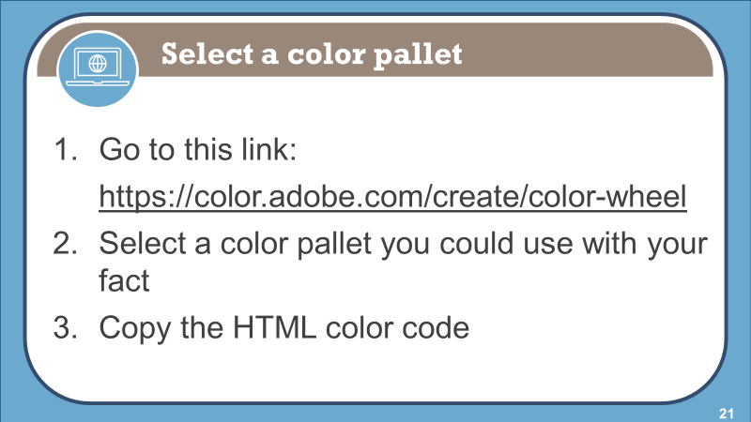  Slide 21 | HTML Color Codes (e.g. #F52D0F)
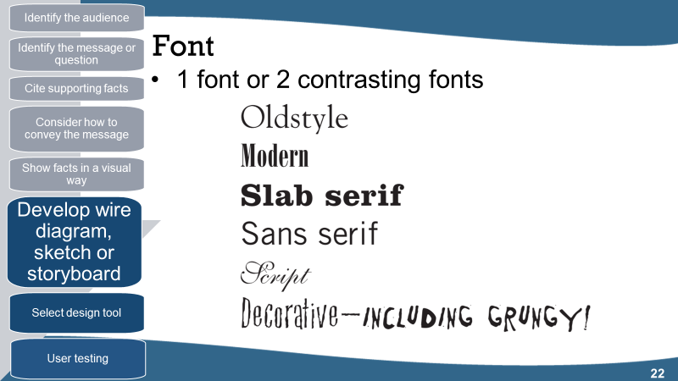  Slide 22 | Decorative & script fonts:  - Only use if there is a purpose  - Use sparingly
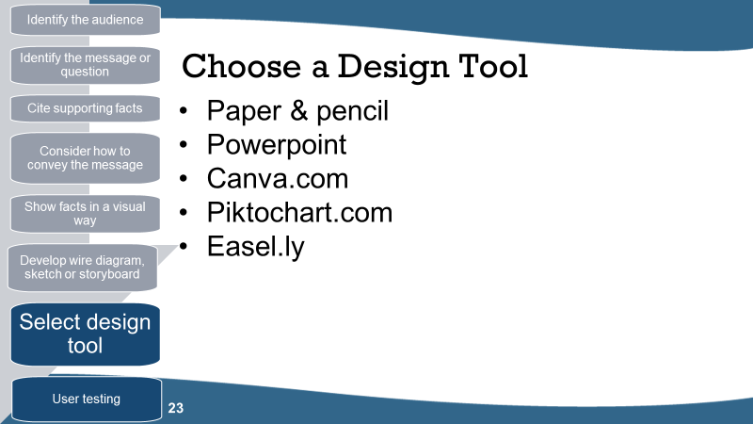
Slide 23
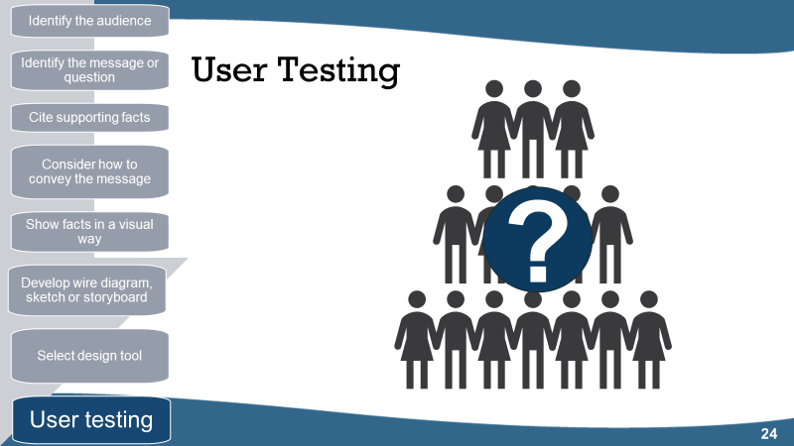 Slide 24
Ask questions like:
- What question does this infographic answer?
- What is the main idea of this infographic?
- Was anything confusing?
- Was there anything you did not understand?
- What jumped out at you?
- What did you like most?

What are your key takeaways for the “Using Infographics in Chemistry” lesson?
_______________________________________________________________
_______________________________________________________________
_______________________________________________________________
_______________________________________________________________
_______________________________________________________________
Do you have any questions?
_______________________________________________________________
_______________________________________________________________
_______________________________________________________________
_______________________________________________________________
